CCT College Dublin

Assessment Cover Page

Module Title: | Machine Learning / Data Visualisation Techniques
Assessment Title: | Integrated CA 2
Lecturer Name: | Dr. Muhammad Iqbal / David Mc Quaid
Student Full Name: | Karina Francieli Schmidt
Student Number: | 2023314
Assessment Due Date: | 26^{h} May 2024
Date of Submission: | 26^{h} May 2024

Declaration

By submitting this assessment, I confirm that I have read the CCT policy on Academic Misconduct and understand the implications of submitting work that is not my own or does not appropriately reference material taken from a third party or other source. I declare it to be my own work and that all material from third parties has been appropriately referenced. I further confirm that this work has not previously been submitted for assessment by myself or someone else in CCT College Dublin or any other higher education institution.

About dataset

The datasets used for this project were found by searching the internet on the 'kaggle' website. One of them was about shopping in the city of Istanbul in Turkey. It contains data from 10 different shopping centres between the years 2021 and 2023. It contains different ages, genders, payment methods, items bought, quantity of each item, customer ID, so it's possible to assess customers' shopping habits.
The second dataset used is about women's clothing e-commerce, which comprises different departments (or types of clothing): clothin ID, age, title, review test, rating, positive feedback, devision name, department name and class name.

Exploratory Data Analysis (EDA)

Data Understanding – Market Basket

To start the python project, you call up the libraries that you will need to apply the codes. The libraries provide functions and methods for manipulating the data and creating graphs, utilising code that has been used before to create a standard. Combining these libraries significantly increases the efficiency and effectiveness of the data analysis process, allowing analysts to focus more on interpreting the data and less on the complexity of the code.
After importing the dataset, the ".head(). function allows you to visualise the data from the first few rows. Meanwhile, using the ".shape" and ".info" functions, it's possible to get a better view of the information in the data. This shows that there are 99457 rows and 10 columns, indicating object, that seven present categorical values, there is two column with integer values (int64)and one float 64.

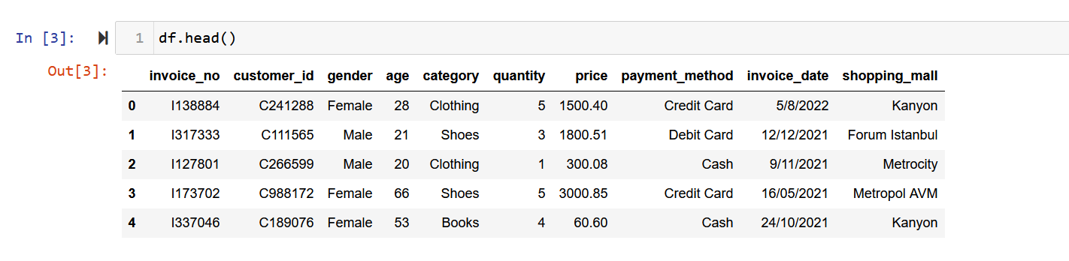
Figure 1 – Dataframe head

In this dataset, there are no missing values in any of the columns, so it wasn't necessary in this df to apply codes to fill in missing values.
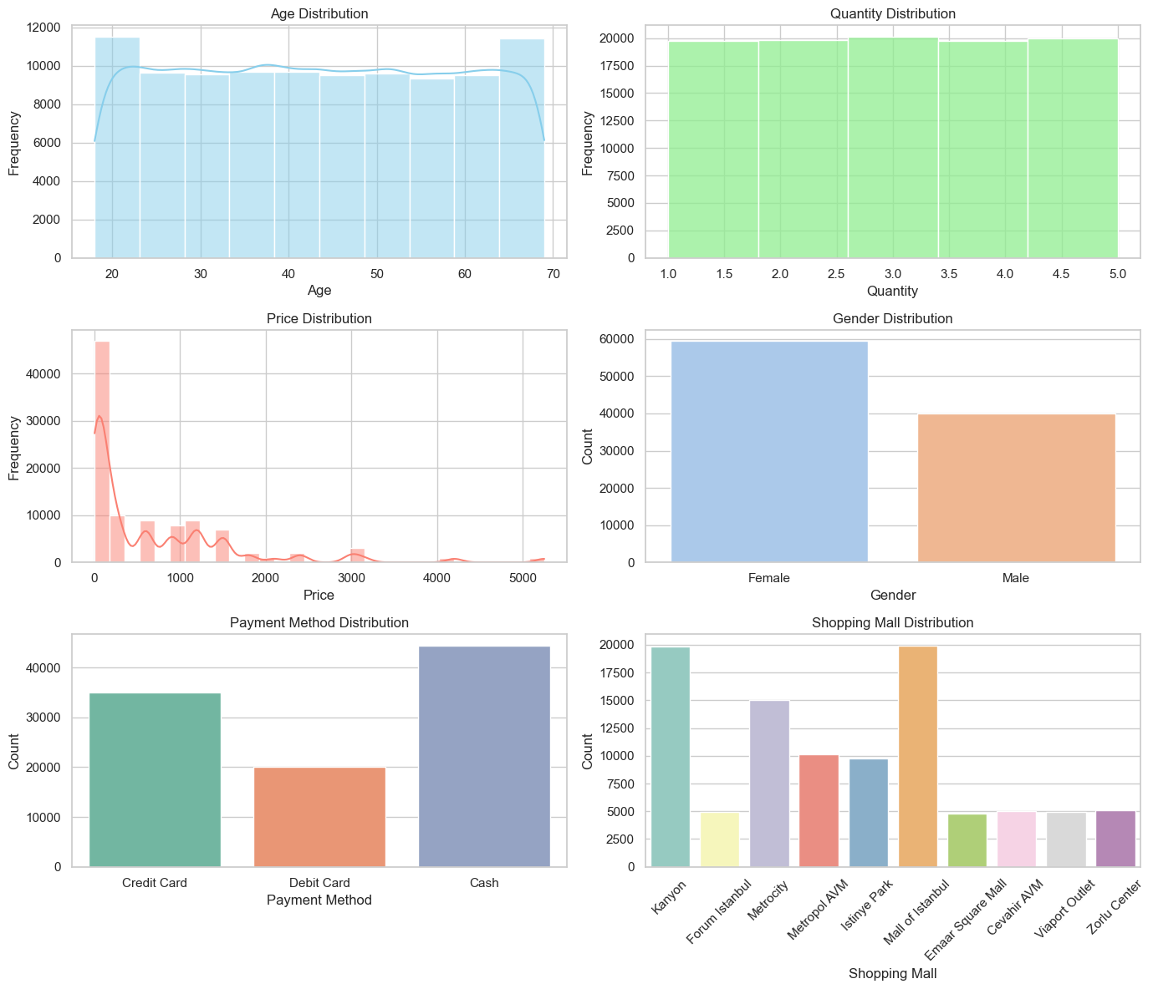
Figure 2 - Distribution

In figure 2, we have historiograms of the distribution of purchases for some of the columns. For age, the graph shows that we have a uniform distribution, with an average age of 43. For quantity, we can see that the purchase of 2 to 4 items is common among consumers. While one and five items is the least frequent, this shows that customers usually buy few items on each trip to the shopping centre. The price histogram is skewed to the right, showing that most purchases are at the lower end of the price spectrum, with fewer high-value transactions. This is typical in retail environments, where lower-priced items are bought more frequently.
When it comes to buying goods, the number of purchases made by women is infinitely higher when compared to those made by men. In terms of payment methods, customers often pay in cash, followed by credit cards and debit cards, even taking into account the country's habits of preferring to pay in cash or by card. And finally, the graph of the distribution of purchases in the different shopping malls shows that the two with the highest number of purchases are Mall of Istanbul and Kanyon, there are several values that can lead to the number of purchases in these two shopping malls, being location, size, type of shop and whether or not there are restaurants (places to eat).
Figure 3 below, evaluating the descriptive statistical analysis, shows that the lowest sales value is 5.23 and the highest is 26,250.00. The average is 2,528.90, which shows the weighted average point. The median sales value is 600.00. This shows that half of all sales are less than this value and the other half are more. In the 25% quantile the sales values are less than 136.00 and the 75% quantile the sales values are less than 2700.00.
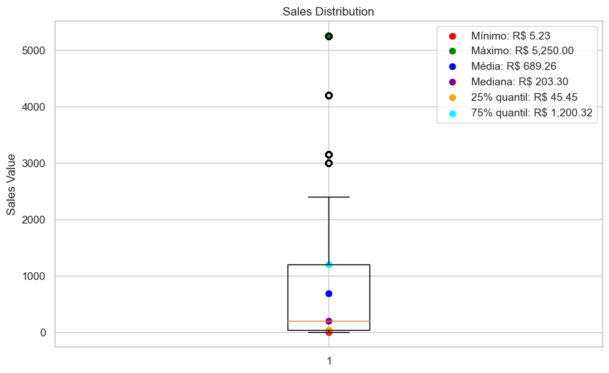
Figure 3 – Box plot distribution price

Transforming some categorical columns into numerical ones is often necessary to make the data suitable for algorithms that require numerical input, improving the versatility of the dataset for various analyses and machine learning models. In this way, the ‘gender’ column was transformed into a numeric column where a row in the ‘gender’ column with the value ‘Female’ was replaced by 0, and a row in the ‘gender’ column with the value ‘Male’ was replaced by 1.

- Sales by Gender:

As shown above, the frequency of purchases by women at shopping centres in Istanbul is higher when compared to men. Figure 4 above also shows the most common items bought by both genders. So, when we compare the genders with the shopping categories, we see a pattern of purchases, with both genders shopping more frequently, the three most commonly purchased being: clothing, cosmetics, food & beverage and shoes. There is also a pattern of purchases in the over-40s, where both categories are bought more frequently.
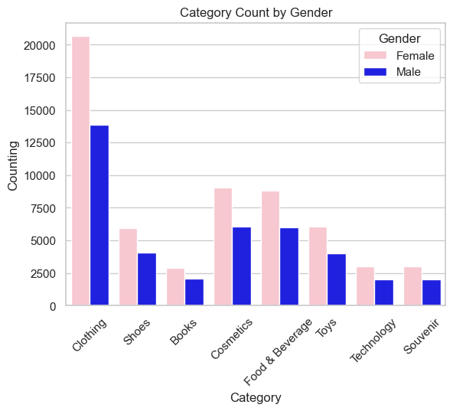
Figure 4 – Category Count by Gender

- Sales by Items:

In the figure 5 below, shows the best-selling categories by age. In the book category there is a similarity of purchase across all ages, but the highest sales are between the ages of 32-40 and 51-60. In the Clothing and Cosmetics category, the age groups are 21-30 and 31-40, which shows a great interest in fashion and beauty products among young adults and middle-aged adults. The technology category peaks in the 41-50 age group, indicating a greater interest among this demographic, potentially for personal and professional use. In the children's toys category, it's actually more popular with younger people. The 61+ age group has a continuing or even necessary interest in food & beverage and technology.

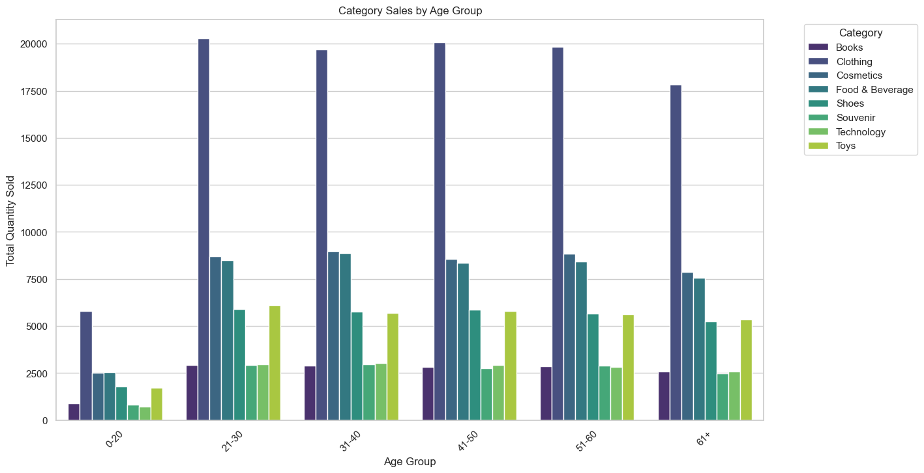
Figure 5 - Category Sales by Age Group
- Sales by period:

A figura 6 abaixo, mostra o número de vendas entre Janeiro/2021 a Março/2023. Há flutuação nas vendas ao longo dos meses com picos que podem indicar vendas mais altas durante meses específicos, o que pode estar relacionado a efeitos sazonais, campanhas promocionais ou dinâmica de mercado. Há uma queda notável nas vendas no último mês mostrado (março de 2023), o que pode indicar uma queda nas vendas ou talvez dados incompletos para esse mês.
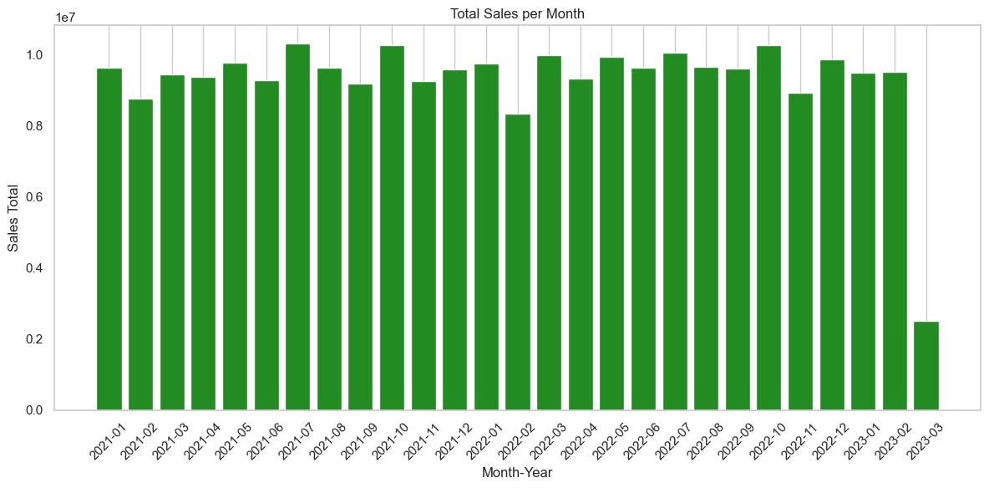
Figure 6 – Total Sales per Month

- Payment methods:

Figure 7 below shows a breakdown of how different age groups prefer the payment methods: cash, credit card and debit card. The categories are divided into age groups: 0-20, 21-30, 31-40, 41-50, 51-60 and 61+. These groups help to analyse the preference for payment methods at different stages of life. In all age groups, the highest frequency of payment is by cash, followed by credit card and debit card. The 0-20 age group shows a much lower frequency than the others. This is due to the fact that only 18-20 year olds are actually assessed, which means a better group than the others, which may explain the lower number of payment types.

-

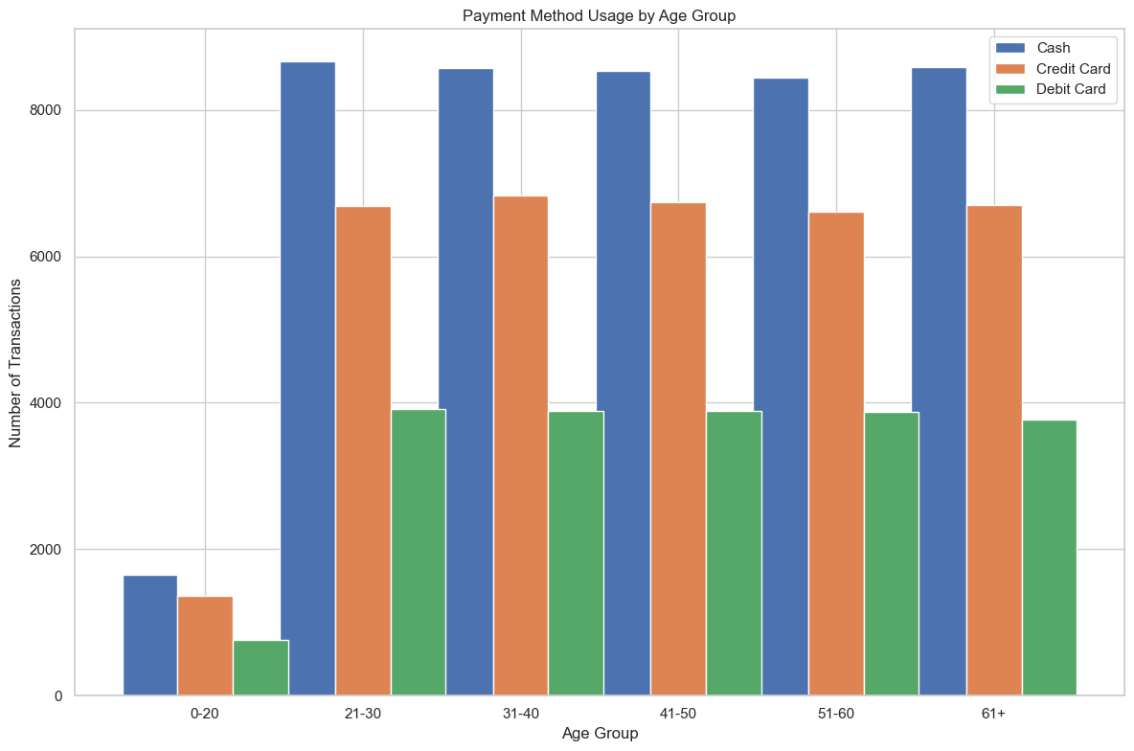
Figure 7 – Payment Method Using by Age Group

- Shopping Mall Sales:

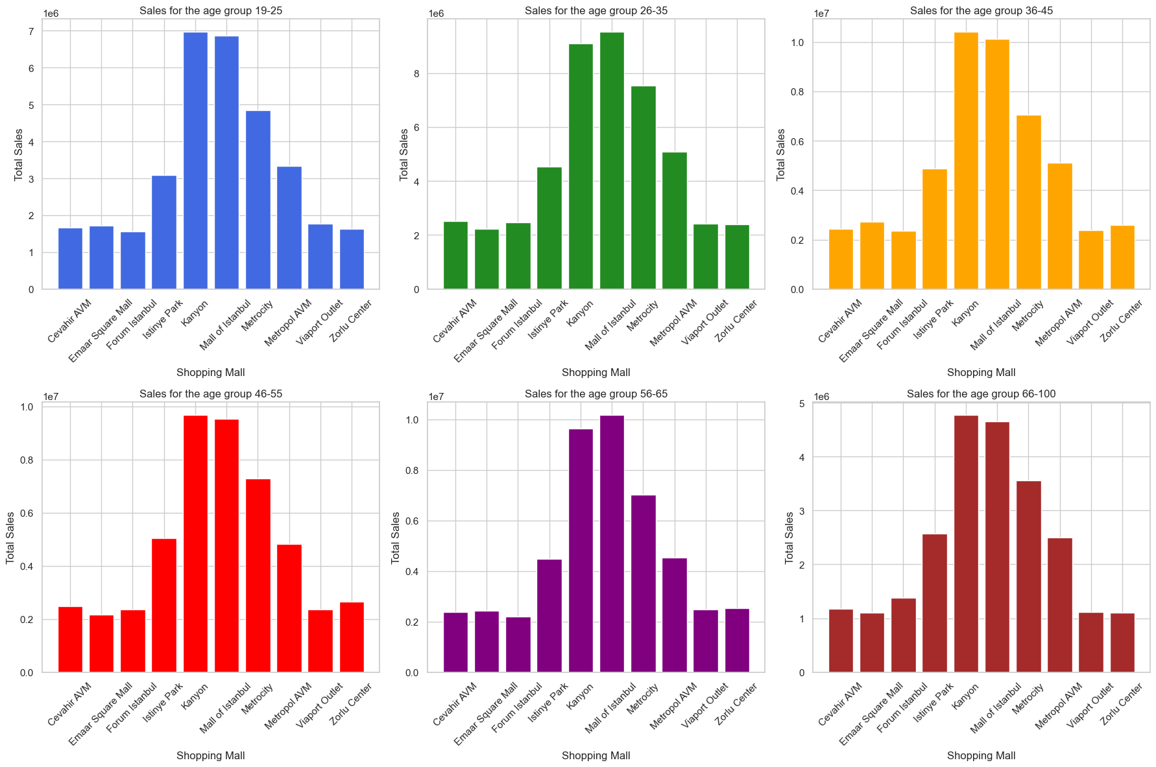
Figure 8 – Shopping Mall Sales by Age Group

Figure 8 illustrates the distribution of total sales across various shopping malls for distinct age groups. Each graph represents a specific age demographic and shows the total sales in each shopping mall within that age group. The preferences among the age groups are very similar, as all the shopping malls with the most purchases are Mall of Istanbul, Kanyon and Metrocity. What may influence the purchases of the different age groups is that they prefer shopping centres with more accessible facilities or those located in residential areas.

Machine Learning

The Market Basket Analysis (MBA) technique is used to understand the relationships between items in large data sets, especially in retail contexts.
Para o data que foi analisado o padrão de vendas utilizando market basket, analisando a categoria (items) comprados não existiu uma correlação de compras entre eles.

Data Understanding – Recommendation System

After importing the dataset, the ".head(). function allows you to visualise the data from the first few rows. Meanwhile, using the ".shape" and ".info" functions, it's possible to get a better view of the information in the data. This shows that there are 23486 rows and 11 columns, indicating object, that five present categorical values, there is nine column with integer values (int 64).

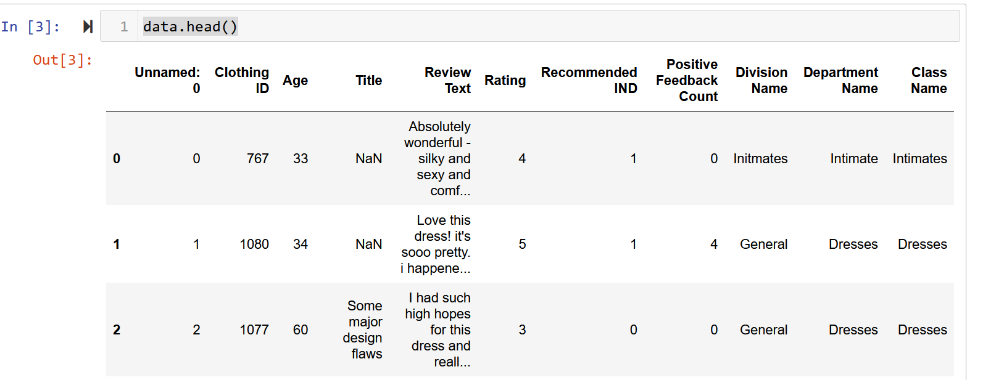
Figure 9 – Data Head (clothing)

With regard to missing data, there are two columns with missing values, ‘Title’ and ‘Review Text’. Dealing with missing values in data sets is essential in machine learning, as most algorithms need all data points to function properly and avoid distortions. Accurately replacing missing data guarantees the integrity and quality of the model, directly influencing the accuracy and effectiveness of the prediction.
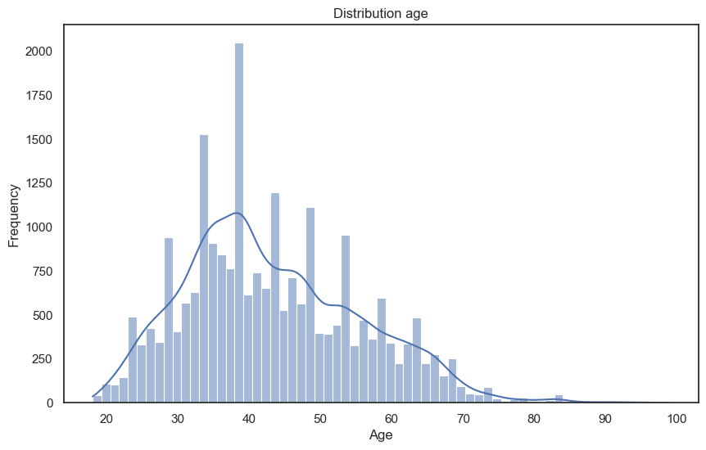
Figure 10 – Distribution Age by Sales Clothing

Image 10 shows the distribution of purchases in different age groups by means of a histogram with an overlaid density line. The graph shows age ranges from 0 to 100. The highest point on the graph is in the 40s, indicating that the majority of customers are in this age group. There are fewer consumers in the older age groups, but it is still possible to see significant activity up to the age of 80.Podemos dizer também que a distribuição está deslocada a esquerda na faixa etaria mais jovem, com diminuição ao longo que a idade aumenta.

Machine Learning

Root Mean Square Error (RMSE) is useful for evaluating the accuracy of model forecasts, helping to assess their ability to perform under real conditions by quantifying errors in an understandable way. In this study of women's clothing e-commerce, the RMSE was 4.30. This amount can be positive or negative depending on the average price you are dealing with. Even though this database doesn't include a column with the value, as we're working on a fashion project, it's well known that clothes don't have very high values. So the amount of 4.30 in this situation can be considered high. We know that the closer the RMSE value is to zero, the better the model.
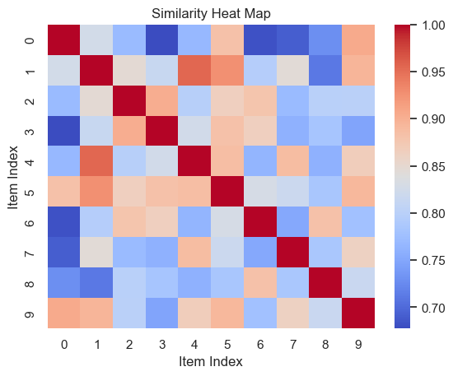
Figure 11 – Similary Heat Map for KNN

KNN can be used to anticipate user preferences and suggest items using the similarity of ratings between users or items. The heat map shows the similarities between items on a scale of 0 to 1, where 1 represents high similarity and 0 no similarity. Each coloured region of the map represents similarity, with red indicating high similarity and lighter colours indicating lower similarity. In this way, it is effective in detecting what the purchasing patterns are, such as which items are purchased together.

Dashboard

The same set of data on women's fashion e-commerce, with an emphasis on the 18-35 age group, was used to develop the dashboard. The ‘dash’ package had to be installed in order to use the dash library. As previously mentioned, the dataset has 11 columns and 23486 rows, five of which had missing values and were filled in.

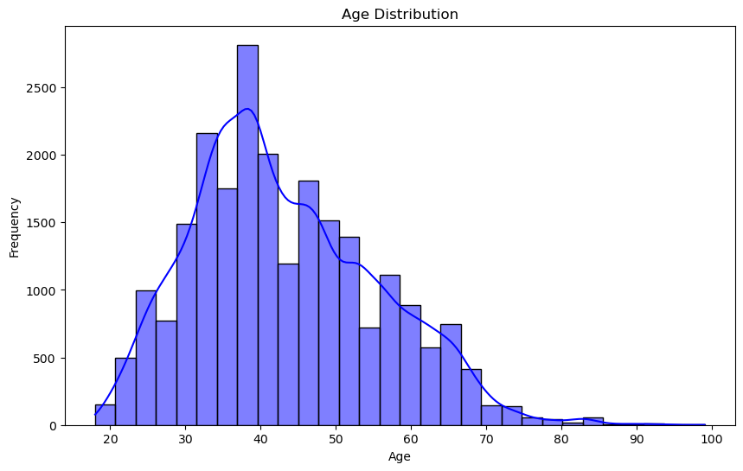
Figure 12 – Age Distribution by Clothes

This graph (figure 12) represents the distribution of ages in comparison with the frequency of online purchases of women's clothing. The bars indicate how many times people aged between 20 and 100 made purchases. The graph indicates that the most common age group for purchases is 40 years old. And it continues to decrease until it reaches 80 years of age.
Para começar o dashboard, foi utilizado o Plotly, uma biblioteca que auxilia na criação de dashboards, juntamente com outras opções disponíveis. Posteriormente, o código foi utilizado para fazer a triagem de idades entre 18 e 35 anos, porque essa é a idade-alvo. A etapa seguinte envolve a utilização do código para iniciar um projeto de painel.
Refine the dataset by selecting records with ages ranging from 18 to 35 years specified in the 'Age' column. Therefore, choosing just the values (ages) that are important. The interactive dashboard's appearance will be determined by another code using Dash, a Python library for developing analytical web applications. This dashboard was created to examine purchasing patterns of women's clothing in e-commerce, with tools to investigate age-related trends within each department.
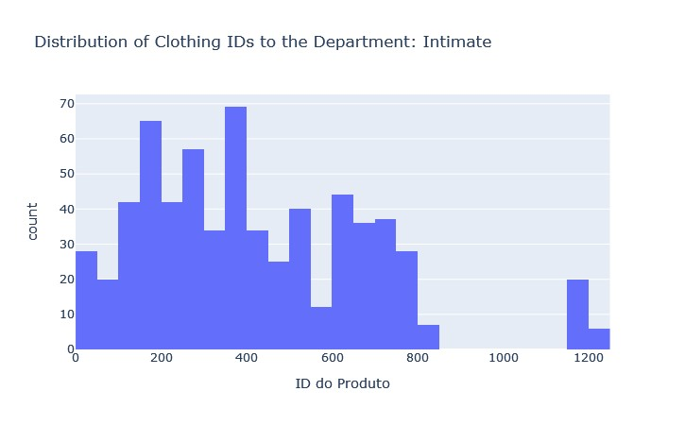
Figure 13 – Image Dashboard

In figure 13, only by choosing the ‘intimate’ option can we access information about the products in this category according to the age selected. The dashboard has provided an interactive way of analysing clothing purchasing trends in various departments and age groups, enabling users to make a detailed and accurate analysis according to their interests.
This dashboard, ideally developed on platforms like Dash with Plotly support, enables not only real-time sales performance monitoring but also quick adaptation to changes in consumer behaviour.

Conclusion

Companies looking to fully understand consumer behaviour and adjust their business strategies effectively need to use graphs, distributions, machine learning tools and libraries. Each graph contains useful data that can be merged into an interactive dashboard to continuously show market trends and consumer preferences in real time.
In addition, the evaluations serve as a solid basis for urban planning and targeted marketing strategies. In short, integrating these visualisations into a single dashboard offers companies a powerful tool for making informed decisions, predicting future demands and customising experiences to meet the specific needs of their customers, helping to strengthen their position in the competitive market.

References

1 - Han, J., Pei, J. and Kamber, M., 2011. Data mining: concepts and techniques. 3rd ed. Morgan Kaufmann Publishers Inc. This book provides a comprehensive overview of data mining techniques and concepts, including market basket analysis and machine learning.

2 - Aggarwal, C.C., 2016. Recommender Systems: The Textbook. Springer. This textbook is a comprehensive reference covering various aspects of recommendation systems, from fundamentals to advanced algorithms and applications.

3 - Berry, M.J.A. and Linoff, G., 2004. Data Mining Techniques: For Marketing, Sales, and Customer Relationship Management. 2nd ed. Wiley Publishing. This book discusses various data mining techniques with practical applications in marketing, including market basket analysis.

4 - Few, S., 2006. Information Dashboard Design: Displaying Data for At-a-Glance Monitoring. Analytics Press. This book focuses on the design of information dashboards, offering practical tips for creating effective visualizations that facilitate monitoring and decision-making.

5 - Hastie, T., Tibshirani, R. and Friedman, J., 2009. The Elements of Statistical Learning: Data Mining, Inference, and Prediction. 2nd ed. Springer. This book is a fundamental reference for statistical machine learning, providing a technical and detailed approach to the methods used in machine learning and their applications.

